**User Guide for Souvenir Store**

**Version 1.0**

**REVISION HISTORY**

|  |  |  |  |
| --- | --- | --- | --- |
| **Version** | **Author** | **Release Date** | **Summary of Changes** |
| 1.0 | SE23PT02 | 03/04/2015 | Initial Version |
|  |  |  |  |

Table of Contents

**1.** **INTRODUCTION** 4

**2.** **LOGIN** 4

**3.** **STORE KEEPERS** 5

**4.** **CATEGORY** 6

**5.** **VENDOR** 7

**6.** **PRODUCT** 8

**7.** **DISCOUNT** 9

**8.** **MEMBERS** 10

**9.** **BILLING** 12

**10.** **REPORTS** 14

**11.** **LOGOFF** 15

1. **INTRODUCTION**
   1. **Purpose**

This document serves as a guide to the user for using the Souvenir Store application. This document explains the features and functions of each menu item in the application

* 1. **Scope**

This document covers only the usability of the application and no technical or implementation details are covered

1. **LOGIN**
   1. **Description**

The login will allow the user to login to the application

* 1. **Screen**

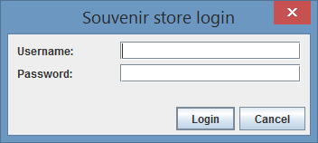

* 1. **Usage**

1. Provide valid User Id and Password and Click “Login” button to login to the application
2. **STORE KEEPERS**
   1. **Description**

The store keeper screen will allow the user to add new store keepers to the system and modify their passwords.

* 1. **Screen**

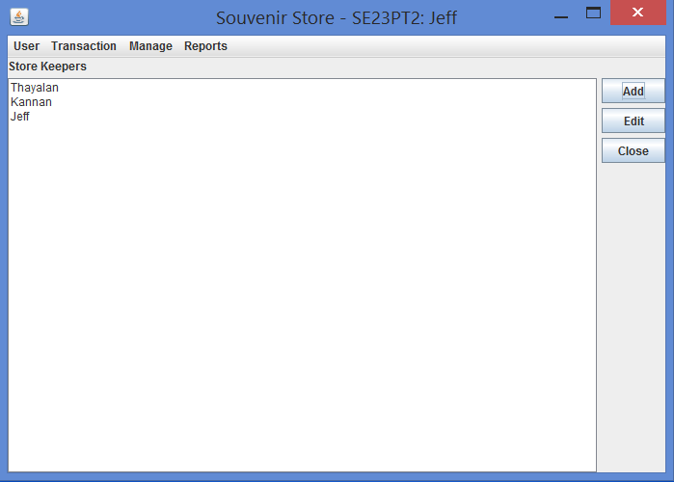

* 1. **Usage**

**Add New Store Keeper**

1. Click on the "Add" button in Store Keeper panel. System opens the "Add StoreKeeper" dialog.

2. Fill the store keeper name, password and confirm password in the appropriate fields.

3. Click "Ok" button to save the store keeper to the system.

4. The newly created store keeper will be listed in the panel, if submission is successful.

**Edit Store Keeper**

1. Select the store keeper in the list that you're going to modify.

2. Click on the "Edit" button in Store Keeper panel. System opens the "Edit StoreKeeper" dialog.

3. Fill the current password, new password and confirm password in the appropriate fields.

4. Click "Ok" button to save the modified store keeper to the system.

1. **CATEGORY**
   1. **Description**

The login will allow the user to login to the application

* 1. **Screen**



* 1. **Usage**

1. Provide valid User Id and Password and Click “Login” button to login to the application
2. **VENDOR**
   1. **Description**

The login will allow the user to login to the application

* 1. **Screen**



* 1. **Usage**

1. Provide valid User Id and Password and Click “Login” button to login to the application
2. **PRODUCT**
   1. **Description**

The login will allow the user to login to the application

* 1. **Screen**



* 1. **Usage**

1. Provide valid User Id and Password and Click “Login” button to login to the application
2. **DISCOUNT**
   1. **Description**

The login will allow the user to login to the application

* 1. **Screen**



* 1. **Usage**

1. Provide valid User Id and Password and Click “Login” button to login to the application
2. **MEMBERS**
   1. **Description**

The member will allow the user to add Members

* 1. **Screen**

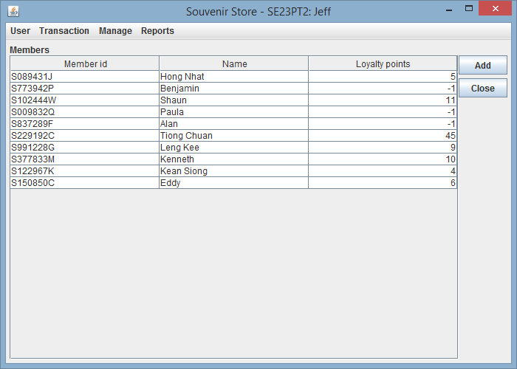

*Member List*

* 1. **Usage**

**Adding Members**

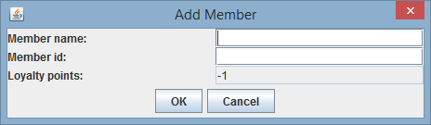

*Adding Member*

1. Press the *“Add”* button on the members panel, the Add Member dialog will be shown.
2. You need to fill in the member name, member id in the provided text field. Loyalty points always start at -1 and is not editable.
3. Press *“OK”* to confirm addition. Press *“Cancel”* to go back to the members panel.

**Editing Members**

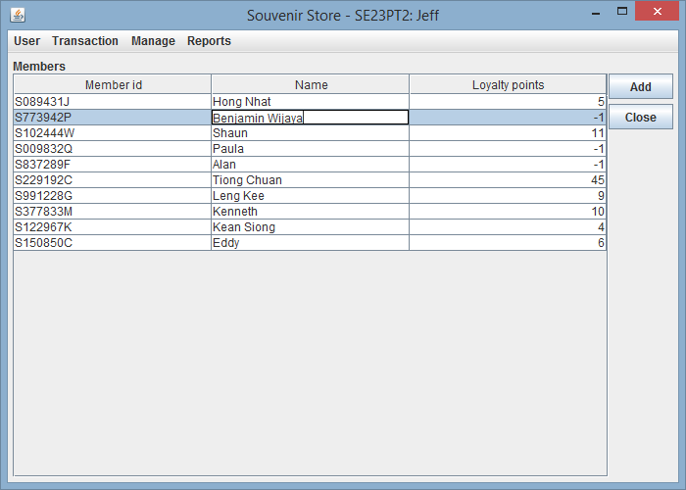

*Editing Member*

1. Simply click on the member’s name that you want to edit. Only the name is editable.
2. **BILLING**
   1. **Description**

The billing screen will allow the user to bill the items, auto-compute discounts, redeem points for members, make the payment and print the receipt upon confirmation.

* 1. **Screen**

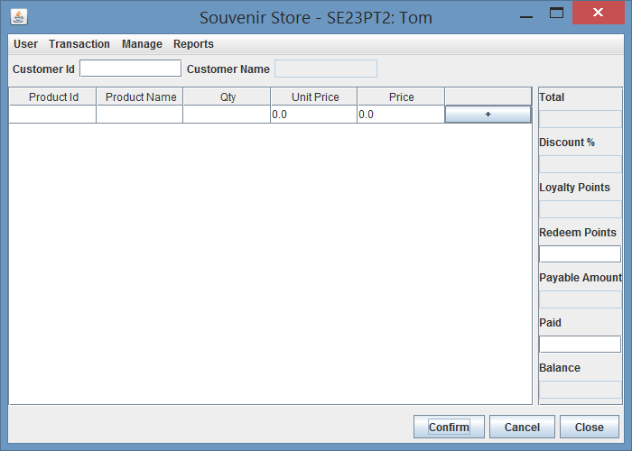

* 1. **Usage**

1. The Billing screen is under Transaction Menu
2. Enter the “Customer Id” (Member ID) and system would do auto-search the members to populate Customer Name, Loyalty points and discount if any
3. If member not found, system would alert the user and continues as “PUBLIC” customer
4. Choose Product Id from the table and system would auto-populate the Product name and unit price
5. The system would auto-populate the qunatity as 1 and computes the price
6. User can change the qty at any time before confirm
7. Click “+” button to add the item to the cart and continue order the next item
8. The previously added item will have “x” button in the last column of the table
9. Click the “x” button to remove the item from the list
10. After adding each item, system auto computes the total, payable amount and the balance (if “Paid” amount was entered)
11. The loylaty points will be displayed for Members
12. Enter points to be redeemed under “Redeem Points” field to deduct points in the payable amount
13. Click “Confirm” to confirm the order, make the payment and print the receipt
14. Click “Cancel” to clear the shopping cart without confirm and make new order
15. Click “Close” to save the shopping cart in session and go to the home page
16. Shopping cart will be auto saved in to the session if user moves to some other screen but will be lost when logged out
17. **REPORTS**

**Transactions Search Screen**

* 1. **Description**

Transaction search page will allow user to find transactions between particular date.

* 1. **Screen**

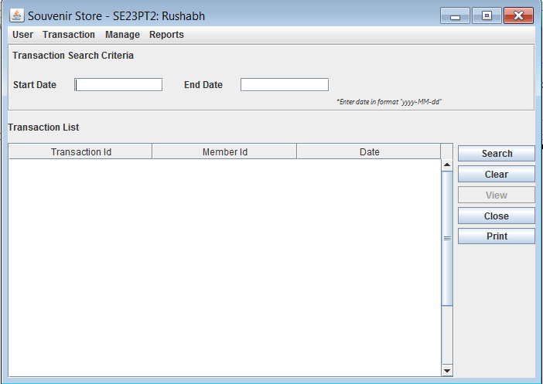

Figure : Initial Screen (View button disabled)

* 1. **Usage**

1. Goto “Reports” tab and select Transaction to go to Transaction search screen. (Figure1)
2. Start Date and End Date are accepted in format “yyyy-MM-dd”.
3. If Start date exceeds End Date then, system will throw error.

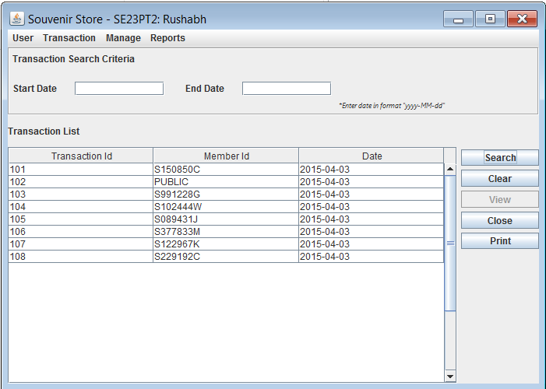

Figure : Transaction List results after clicking "Search" button

* 1. **Usage**

1. “Search” button facilitates user to search transactions between particular dates.
2. After clicking “Search” button if Start Date and End Date both are empty then user will get entire list of Transactions
3. After clicking “Search” button if Start Date is empty and End Date is entered then user will get all Transactions - on or before the End Date.
4. After clicking “Search” button if Start Date is entered and End Date is empty then user will get all Transactions - on or after the Start Date.
5. To retrieve transactions for a particular date user should enter same values of start and end date.

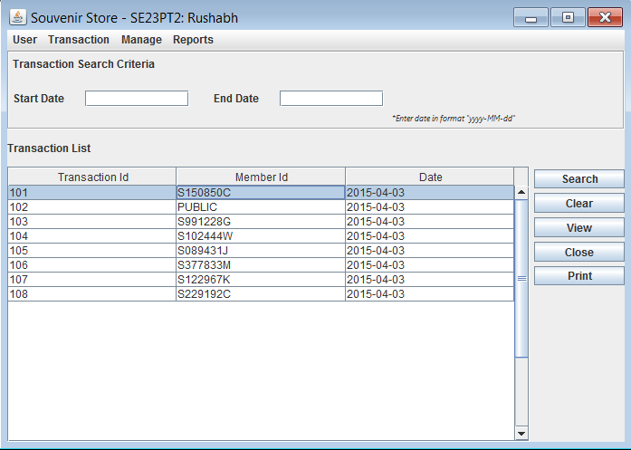

Figure : Selecting a Transaction from List (View button enabled)

* 1. **Usage**

1. After clicking search button user will get list of transaction sorted in ascending order of their transaction Id.
2. Cells in the displayed transaction List are non-editable.
3. User would be able to select only a single record from the displayed Transaction List.
4. Clicking “Clear” button clears the data entered in the start date and end date fields.
5. “View” button will get enabled once the row is selected from the Transaction list.
6. “Close” button will help user navigate to the main window.

**Transactions Details Screen**

* 1. **Description**

Transaction details page will allow user to see product related details like Product id, name, description, Quantity etc.

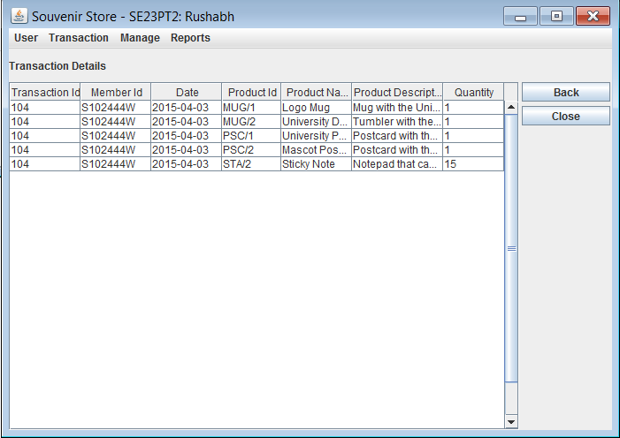

Figure : Transaction details page after clicking View button

* 1. **Usage**

1. On click of “view” button after selecting a particular transaction you will get List of transactions with product details(like product Id, product name, quantity, product description) sorted by the ProductId.
2. When user clicks on “Back” button the user’s search criteria would be retained along with the search results in Transaction search screen.

**Transactions Report Screen**

* 1. **Description**

Clicking “Print” button on Transaction search page will generate report with all transactions between given date range along with the product name, description, order quantity etc sorted with product Id.

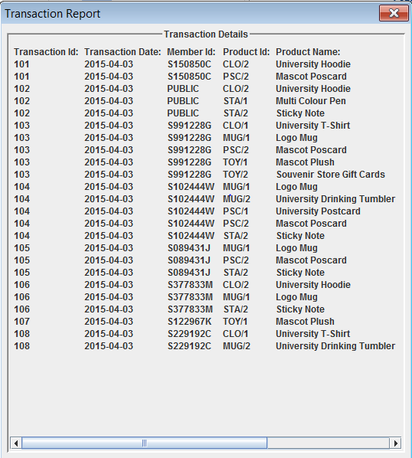

Figure : List of Transactions

1. **LOGOFF**
   1. **Description**

The logoff will allow the user to logout from the application

* 1. **Usage**

1. Click “Logoff” under the User menu to logout of the application